**Ideation Phase**

**Define the Problem Statements**

|  |  |
| --- | --- |
| Date | 03 June 2024 |
| Team ID | SWTID1719997659 |
| Project Name | Book-Nest |
| Maximum Marks | 3 Marks |

**Customer Problem Statement :**

Readers often struggle to efficiently discover, track, and manage their reading interests across various genres and formats due to scattered sources, inconsistent recommendations, and lack of a centralized platform for personalized book suggestions. This fragmentation leads to a disjointed reading experience, making it challenging for users to explore new titles, keep track of their reading progress, and engage in meaningful discussions about books.

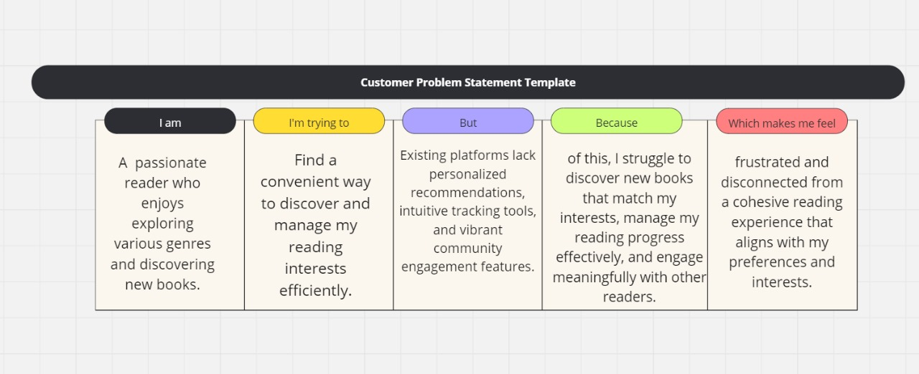

|  |  |  |  |  |  |
| --- | --- | --- | --- | --- | --- |
| **Problem Statement (PS)** | **I am (Customer)** | **I’m trying to** | **But** | **Because** | **Which makes me feel** |
| PS-1 | an avid reader who enjoys exploring diverse genres and discovering new books to read. | find a convenient way to discover and manage my reading interests efficiently. | existing platforms lack personalized recommendations, intuitive tracking tools, and vibrant community engagement features. | of this, I struggle to discover new books that match my interests, manage my reading progress effectively, and engage meaningfully with other readers. | frustrated and disconnected from a cohesive reading experience that aligns with my preferences and interests. |
| PS-2 | a book enthusiast who values discovering new authors and genres, and staying organized in my reading habits. | find a platform that seamlessly integrates personalized book recommendations, comprehensive reading tracking tools, and a vibrant community for book discussions. | current solutions either focus too heavily on commercial bestsellers or lack the functionality to track reading progress and engage in meaningful discussions. | of these limitations, I find it challenging to discover lesser-known gems, keep track of my reading milestones, and connect with a community of readers who share my interests and passion for books. | frustrated by the fragmented nature of existing platforms and the missed opportunities for deeper engagement and discovery in my reading journey. |